AWS Employee Management System using Amazon ECS, Docker, Jenkins CI/CD, and Amazon RDS

NAME : SUBASHREE M
EMAIL ID : subashreem@thestackly.com

README.md.

📌 Project Overview

The AWS Employee Management System is a cloud-based full-stack web application developed to demonstrate the deployment of a modern three-tier architecture on Amazon Web Services (AWS). The application enables users to perform complete employee management operations, including creating, viewing, updating, and deleting employee records.

The project follows DevOps best practices by containerizing the application using Docker, automating deployments with Jenkins CI/CD, storing container images in Amazon ECR, deploying containers on Amazon ECS Fargate, and using Amazon RDS MySQL as the backend database. An Application Load Balancer (ALB) is used to provide reliable access to the backend service.
🚀 Features

- Employee Management (CRUD Operations)
- Add Employee
- View Employee List
- Update Employee Details
- Delete Employee
- Responsive React Frontend
- REST API using Flask
- MySQL Database on Amazon RDS
- Docker Containerization
- CI/CD using Jenkins
- Automated Deployment to Amazon ECS
- Container Images Stored in Amazon ECR
- Backend Routing through Application Load Balancer (ALB)

🛠️ Technology Stack

Frontend

- React.js
- HTML
- CSS
- JavaScript

Backend

- Python
- Flask
- Gunicorn

Database

- Amazon RDS (MySQL)
DevOps Tools

- Docker
- Docker Compose
- Jenkins
- Git
- GitHub

AWS Services

- Amazon EC2
- Amazon ECS (Fargate)
- Amazon ECR
- Amazon RDS
- Application Load Balancer (ALB)
- IAM
- VPC
- Security Groups

🏗️ AWS Architecture

Internet
│
▼
React Frontend (Amazon ECS)
│
▼
Application Load Balancer
│
▼
Flask Backend (Amazon ECS)
│
▼
Amazon RDS (MySQL Database)

🔄 CI/CD Pipeline

Developer
│
▼
GitHub Repository
│
▼
GitHub Webhook
│
▼
Jenkins Pipeline
│
├── Build Backend Docker Image
├── Build Frontend Docker Image
├── Push Images to Amazon ECR
└── Force New Deployment in Amazon ECS
│
▼
Updated Application Available

📂 Project Structure

aws-employee-management-system/
│
├── backend/
│ ├── application.py
│ ├── requirements.txt
│ └── Dockerfile
│
├── frontend/
│ ├── src/
│ ├── public/
│ └── Dockerfile
│
├── database/
│ └── init.sql
│
├── jenkins/
│ └── Dockerfile
│
├── docker-compose.yml
├── docker-compose.jenkins.yml
├── Jenkinsfile
├── Jenkinsfile-ECR
└── README.md

⚙️ Deployment Workflow

- Developer pushes source code to GitHub.

- GitHub Webhook triggers the Jenkins pipeline.

- Jenkins checks out the latest code.

- Backend and frontend Docker images are built.

- Images are pushed to Amazon ECR.

- Jenkins triggers a new deployment for Amazon ECS services.

- ECS pulls the latest images from ECR.

- The backend connects to Amazon RDS.

- Users access the application through the frontend, while backend requests are routed through the Application Load Balancer.

📸 Project Screenshots

- Include the following screenshots in this section:

- Home Page

- Employee List

- Add Employee

- Edit Employee

- Delete Employee

- Jenkins Pipeline Success

- Amazon ECS Services

- Amazon ECR Repositories

- Amazon RDS Database

- Application Load Balancer

- GitHub Repository

💡 Challenges Faced

- Configuring Docker networking between containers.

- Connecting the backend to Amazon RDS.

- Resolving CORS issues between frontend and backend.

- Configuring Amazon ECS task definitions and services.

- Integrating Jenkins with GitHub Webhooks.

- Automating Docker image deployment to Amazon ECR.

- Updating Amazon ECS services automatically after image pushes.

- Configuring the Application Load Balancer for backend routing.

⭐ Conclusion

This project demonstrates an end-to-end cloud-native application deployment using AWS services and DevOps practices. It showcases containerization, continuous integration, continuous deployment, cloud database integration, load balancing, and automated application delivery using Jenkins, Amazon ECR, Amazon ECS, Amazon RDS, and an Application Load Balancer.

Project Objectives

The main objectives of this project are:

- To develop a full-stack Employee Management System with CRUD functionality.
- To build the frontend using React.js and the backend using Flask.
- To store employee data securely in Amazon RDS (MySQL).
- To containerize the application using Docker.
- To deploy the application on Amazon ECS (Fargate).
- To store Docker images in Amazon ECR.
- To automate application deployment using Jenkins CI/CD.
- To gain practical experience with AWS cloud services and DevOps practices.

System Architecture

The AWS Employee Management System follows a three-tier architecture consisting of the Presentation Layer, Application Layer, and Database Layer.

- Presentation Layer: React.js frontend provides the user interface.

- Application Layer: Flask backend processes requests and handles business logic.

- Database Layer: Amazon RDS MySQL stores employee information.

The frontend and backend are containerized using Docker and deployed on Amazon ECS (Fargate). Docker images are stored in Amazon ECR, while an Application Load Balancer (ALB) routes requests to the backend service. A Jenkins CI/CD pipeline automates the build, image push, and deployment process whenever code is pushed to GitHub.

Figure 3.1: AWS Employee Management System Architecture

User
│
▼
Frontend (React)
Amazon ECS (Fargate)
│
▼
Application Load Balancer
│
▼
Backend (Flask)
Amazon ECS (Fargate)
│
▼
Amazon RDS (MySQL)

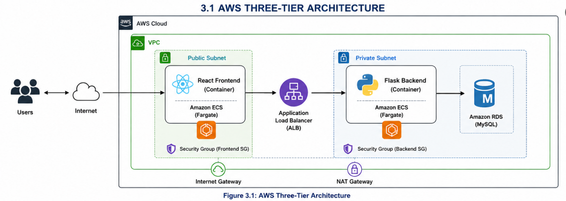

Figure 3.2: Application System Architecture

Employee Management System

👤 User
│
│
▼
+---------------------------+
| React Frontend |
| (Employee UI) |
+-------------+-------------+
│
HTTP/REST API Requests
│
▼
+---------------------------+
| Flask Backend |
| Business Logic & APIs |
+-------------+-------------+
│
SQL Queries (CRUD)
│
▼
+---------------------------+
| Amazon RDS MySQL |
| Employee Database |
+-------------+-------------+
│
Employee Records
│
▼
Employee Details Returned to User

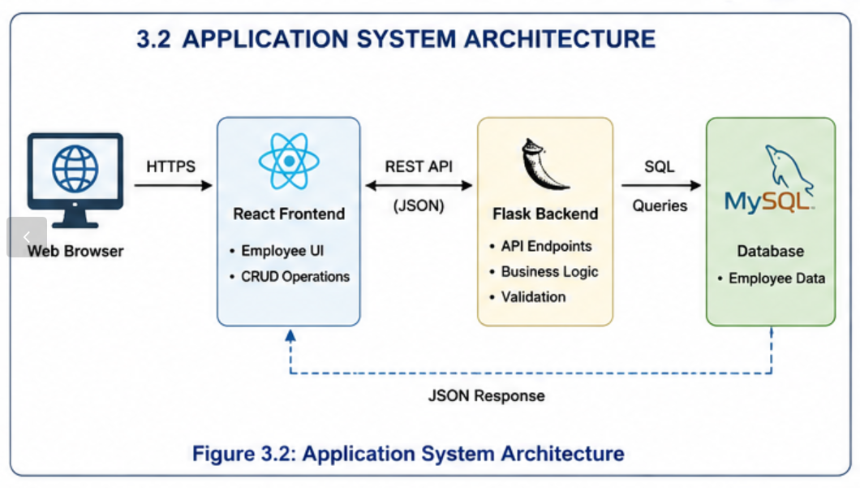

Figure 3.3: CI/CD Architecture

CI/CD PIPELINE

👨‍💻 Developer
│
Push Code to GitHub
│
▼
+---------------------------+
| GitHub Repository |
+-------------+-------------+
│
GitHub Webhook
│
▼
+---------------------------+
| Jenkins Server |
| (CI/CD Pipeline) |
+-------------+-------------+
│
┌──────────────┼──────────────┐
│ │ │
▼ ▼ ▼
Checkout Code Build Docker Build Docker
Backend Image Frontend Image
│ │ │
└──────────────┼──────────────┘
▼
+---------------------------+
| Push Images to |
| Amazon ECR |
+-------------+-------------+
│
Pull Latest Images
│
▼
+---------------------------+
| Amazon ECS (Fargate) |
| Backend & Frontend |
+-------------+-------------+
│
Force New Deployment
│
▼
+---------------------------+
| Updated Employee |
| Management Application |
+---------------------------+

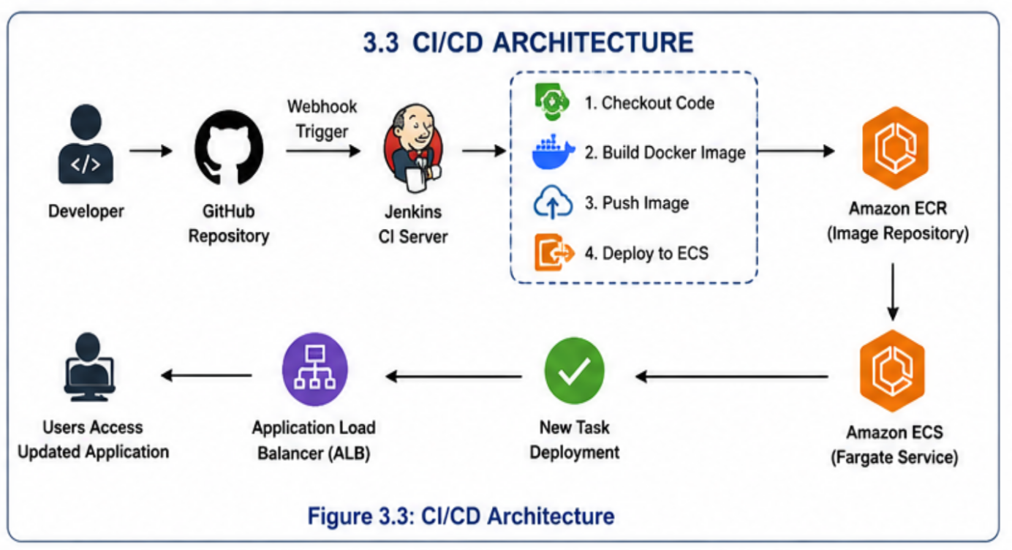

- Technology Stack

The following technologies, tools, and AWS services were used to design, develop, deploy, and automate the Employee Management System.
Category | Technology / Service | Purpose
Frontend | React.js | Develops the user interface for the Employee Management System.
Backend | Flask (Python) | Provides REST APIs and handles business logic.
Programming Language | Python | Backend application development.
Database | Amazon RDS (MySQL) | Stores employee information securely.
Containerization | Docker | Packages the frontend and backend into containers.
Container Registry | Amazon Elastic Container Registry (ECR) | Stores Docker images.
Container Orchestration | Amazon Elastic Container Service (ECS) with AWS Fargate | Deploys and manages containerized applications.
Load Balancer | Application Load Balancer (ALB) | Routes client requests to the backend service.
CI/CD Tool | Jenkins | Automates build, image push, and deployment.
Version Control | Git | Tracks source code changes.
Source Code Repository | GitHub | Hosts the project source code and triggers Jenkins through Webhooks.
Cloud Platform | Amazon Web Services (AWS) | Provides the cloud infrastructure for the application.
Operating System | Ubuntu Linux | Used as the Jenkins host environment.
Web Server | Nginx | Serves the React frontend application.
API Testing | Web Browser / REST API | Used to verify backend API responses during testing.
The combination of these technologies enabled the successful development, deployment, and automation of a scalable cloud-based Employee Management System following modern DevOps practices.

- AWS Services Used

The following AWS services were used in the development and deployment of the Employee Management System.

  - Amazon EC2

Amazon EC2 was used to host the Jenkins server, which automated the build and deployment process. It also provided the environment for Docker and project management
.
5.2 Amazon ECS (Elastic Container Service)

Amazon ECS with AWS Fargate was used to deploy and manage the frontend and backend Docker containers without managing servers.

5.3 Amazon ECR (Elastic Container Registry)

Amazon ECR was used as a private container registry to store Docker images for the frontend and backend applications.

5.4 Amazon RDS (Relational Database Service)

Amazon RDS with MySQL was used to store employee records securely. The backend application connected to the database to perform CRUD operations.

5.5 Application Load Balancer (ALB)

The Application Load Balancer distributed incoming requests to the backend ECS service and provided a single endpoint for API communication.

5.6 IAM (Identity and Access Management)

IAM was used to manage permissions and provide secure access to AWS services for Jenkins, ECS, and other resources.

5.7 Amazon VPC (Virtual Private Cloud)

Amazon VPC provided an isolated networking environment for deploying ECS services, RDS, and the Application Load Balancer securely.

5.8 Security Groups

Security Groups acted as virtual firewalls by controlling inbound and outbound traffic for EC2, ECS, ALB, and RDS instances.

5.9 AWS Fargate

AWS Fargate was used as the launch type for Amazon ECS, allowing containers to run without provisioning or managing EC2 instances.

- Project Workflow

The Employee Management System follows a simple and efficient workflow from user interaction to data storage and automated deployment.

Workflow Steps

- The user opens the Employee Management System through the React frontend.
- The frontend sends HTTP requests to the Flask backend using REST APIs.
- The backend processes the request and validates the data.
- The backend performs CRUD operations on the Amazon RDS MySQL database.
- The database returns the requested information to the backend.
- The backend sends the response back to the frontend.
- The frontend displays the updated employee information to the user.

Deployment Workflow

1.The developer pushes the latest source code to the GitHub repository.
2.GitHub Webhook automatically triggers the Jenkins pipeline.
3.Jenkins checks out the latest source code.
4.Docker images for the frontend and backend are built.
5.Jenkins pushes the Docker images to Amazon ECR.
6.Jenkins forces a new deployment of the Amazon ECS services.
7.Amazon ECS pulls the latest Docker images from Amazon ECR.
8.The updated application becomes available to users automatically.

Figure 6.1: Project Workflow

User
│
▼
React Frontend
│
HTTP Request
▼
Flask Backend
│
CRUD Operations
▼
Amazon RDS (MySQL)
│
Response
▼
React Frontend
│
▼
User

7. Jenkins CI/CD Pipeline

A Continuous Integration and Continuous Deployment (CI/CD) pipeline was implemented using Jenkins to automate the build and deployment process. Whenever changes are pushed to the GitHub repository, Jenkins automatically executes the pipeline and deploys the latest version of the application.

Pipeline Stages

7.1 Source Code Checkout
Jenkins retrieves the latest source code from the GitHub repository.

7.2 Docker Image Build
Docker images are built separately for the frontend and backend applications using their respective Dockerfiles.

7.3 Push Images to Amazon ECR
The newly built Docker images are tagged and pushed to Amazon Elastic Container Registry (ECR).

7.4 Deploy to Amazon ECS
Jenkins updates the Amazon ECS services by forcing a new deployment. Amazon ECS then pulls the latest Docker images from Amazon ECR and deploys the updated containers.

7.5 Deployment Verification
After deployment, the application is verified by accessing the frontend and testing CRUD operations to ensure the latest version is running successfully.

Pipeline Workflow

Developer
│
▼
GitHub Repository
│
▼
GitHub Webhook
│
▼
Jenkins Pipeline
│
├── Checkout Source Code
├── Build Backend Docker Image
├── Build Frontend Docker Image
├── Push Images to Amazon ECR
└── Force New Deployment in Amazon ECS
│
▼
Updated Employee Management System

Project Screenshots

GitHub Repository:
https://github.com/subashree21/aws-employee-management-system.git

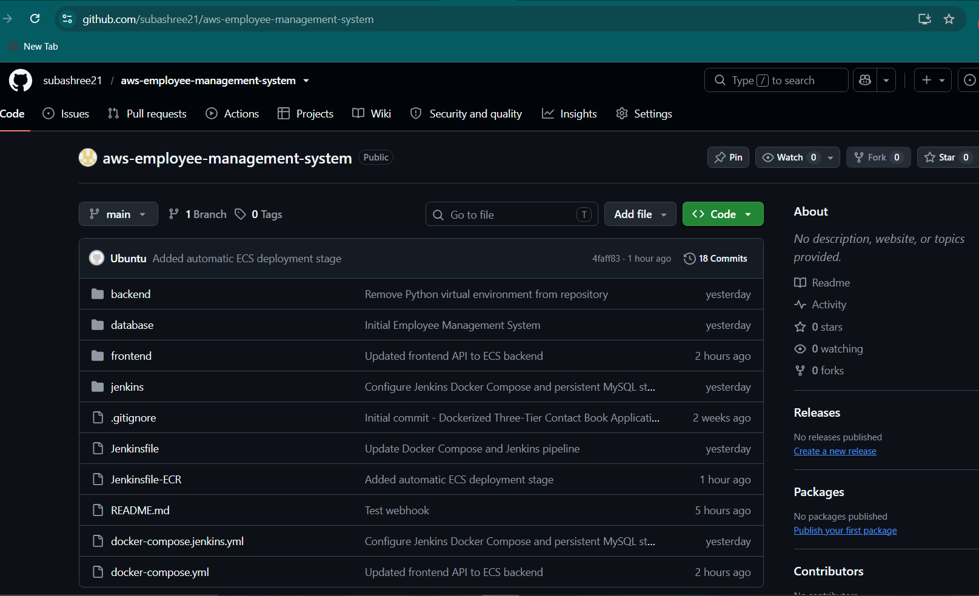

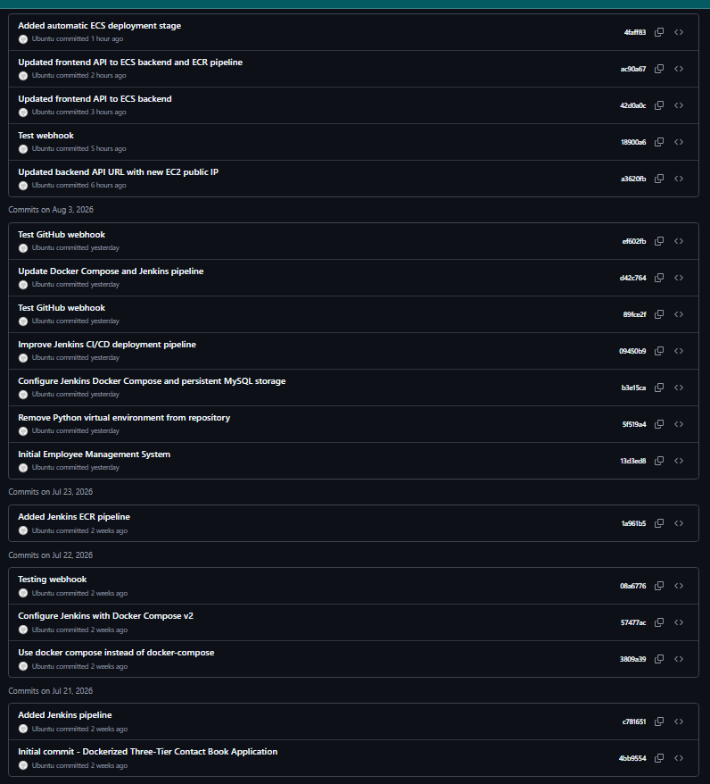

Jenkins Dashboard

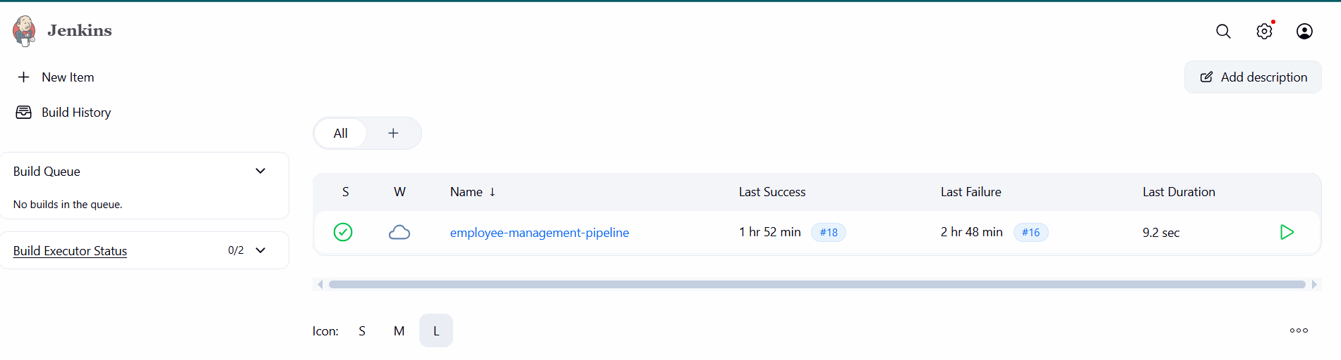
jenkins Pipeline –Build Success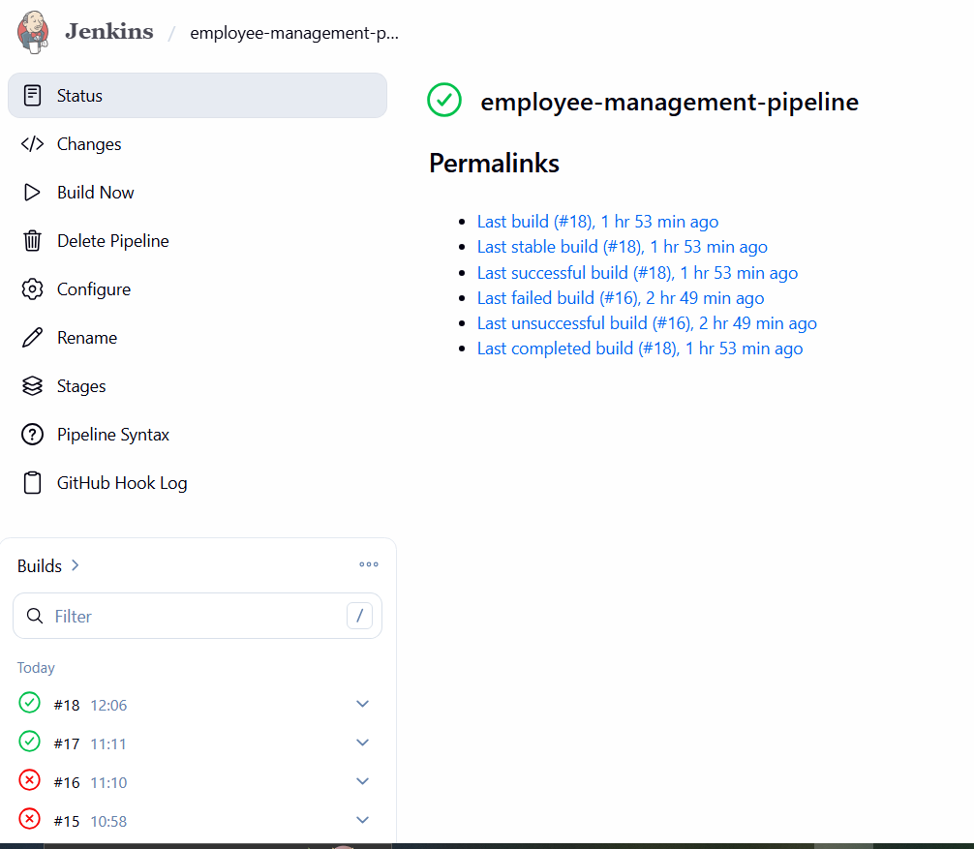

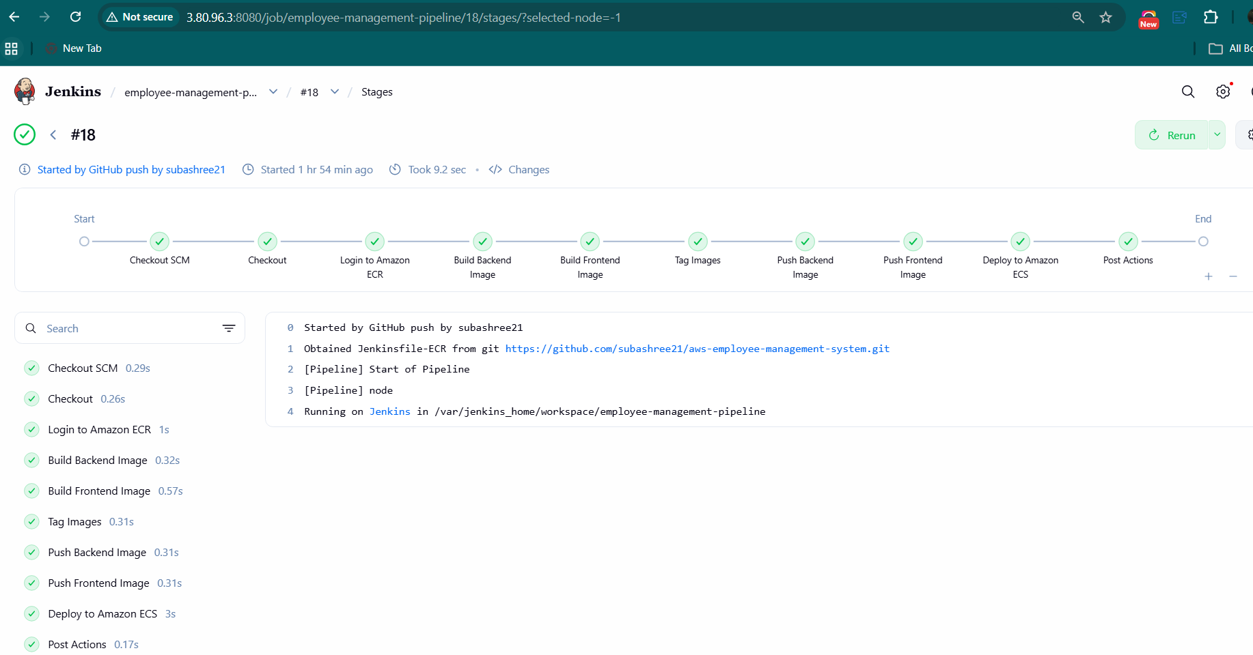

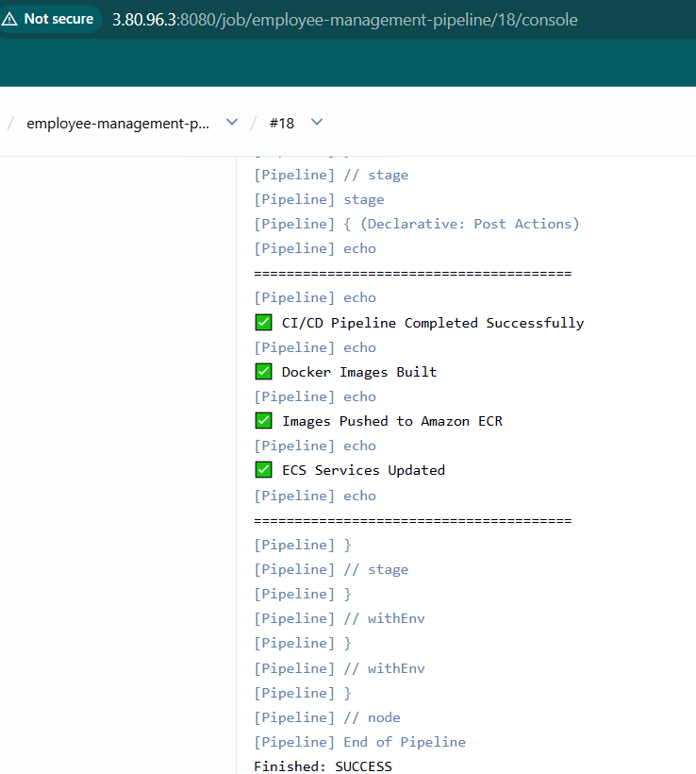

Amazon ECR Repositories

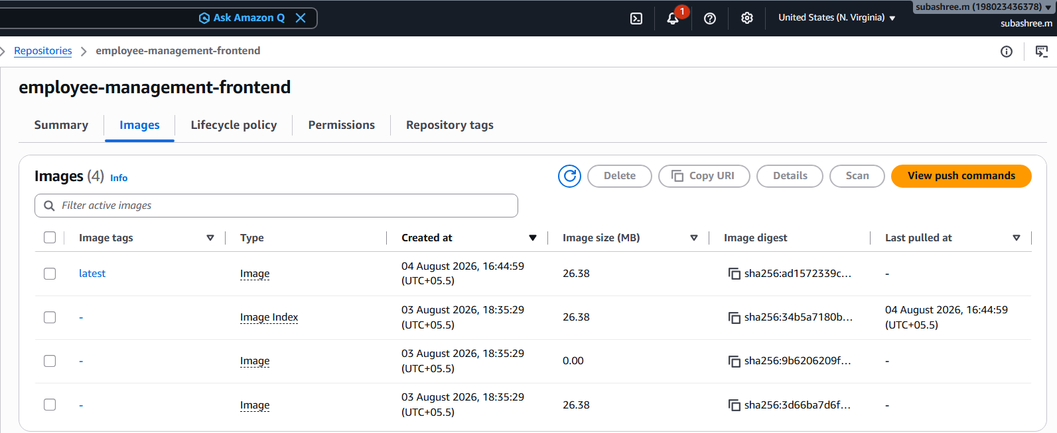

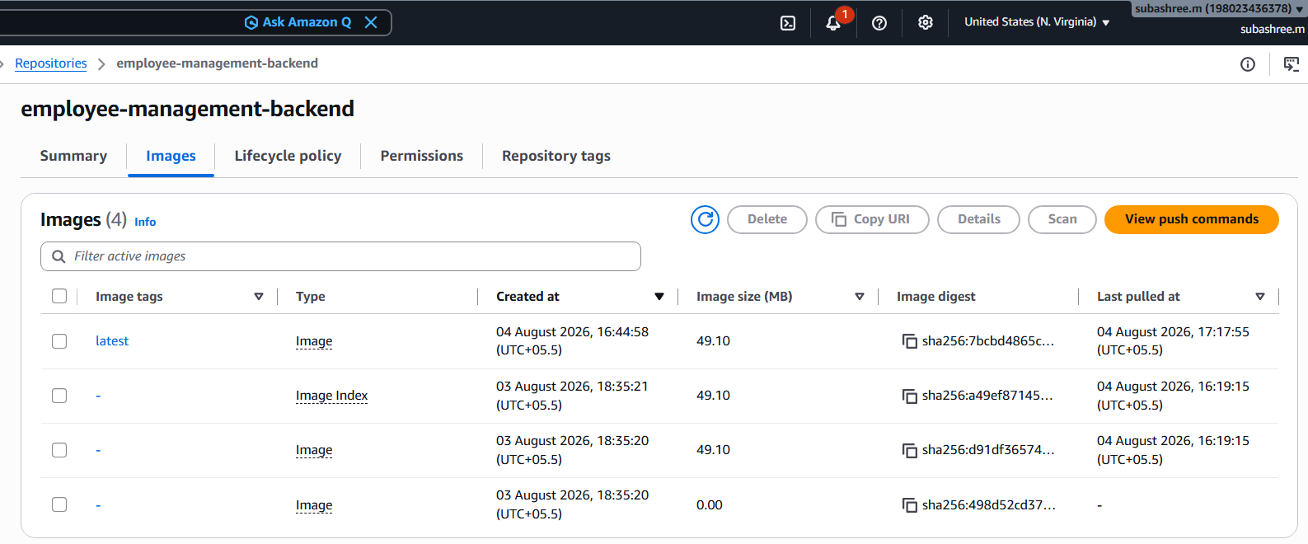

Amazon ECS Cluster

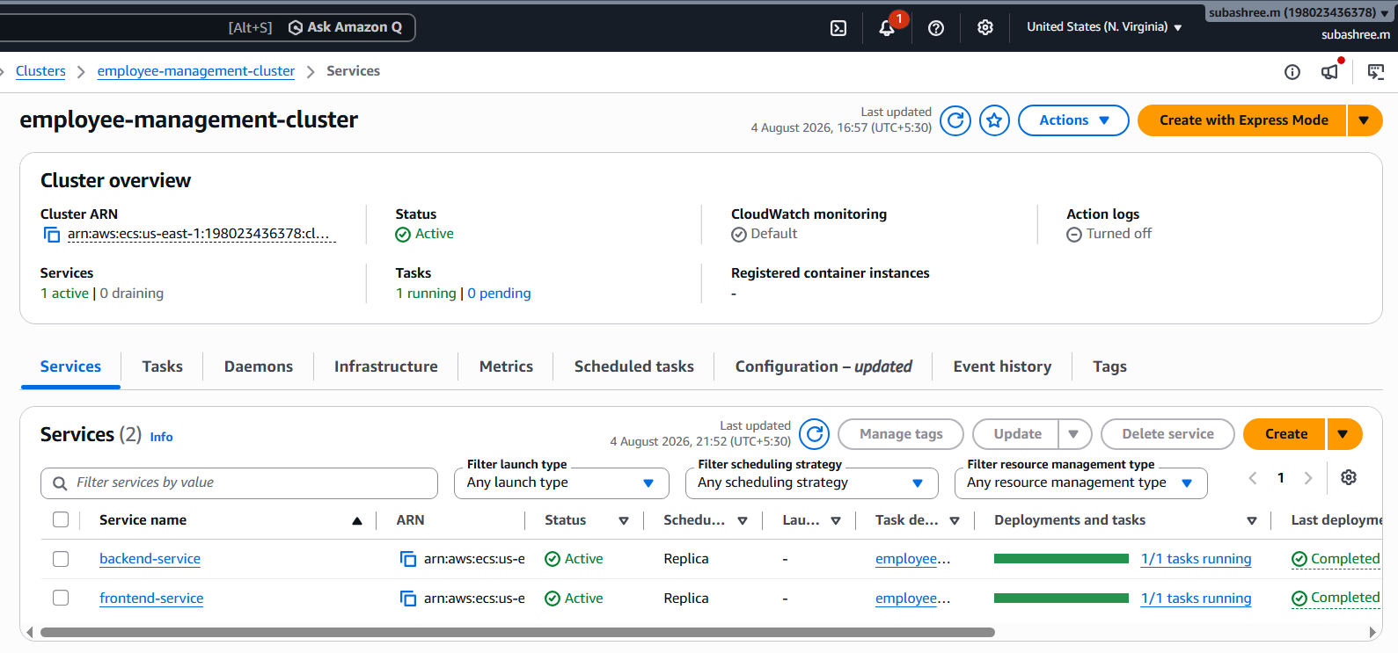

Amazon ECS Services

Backend

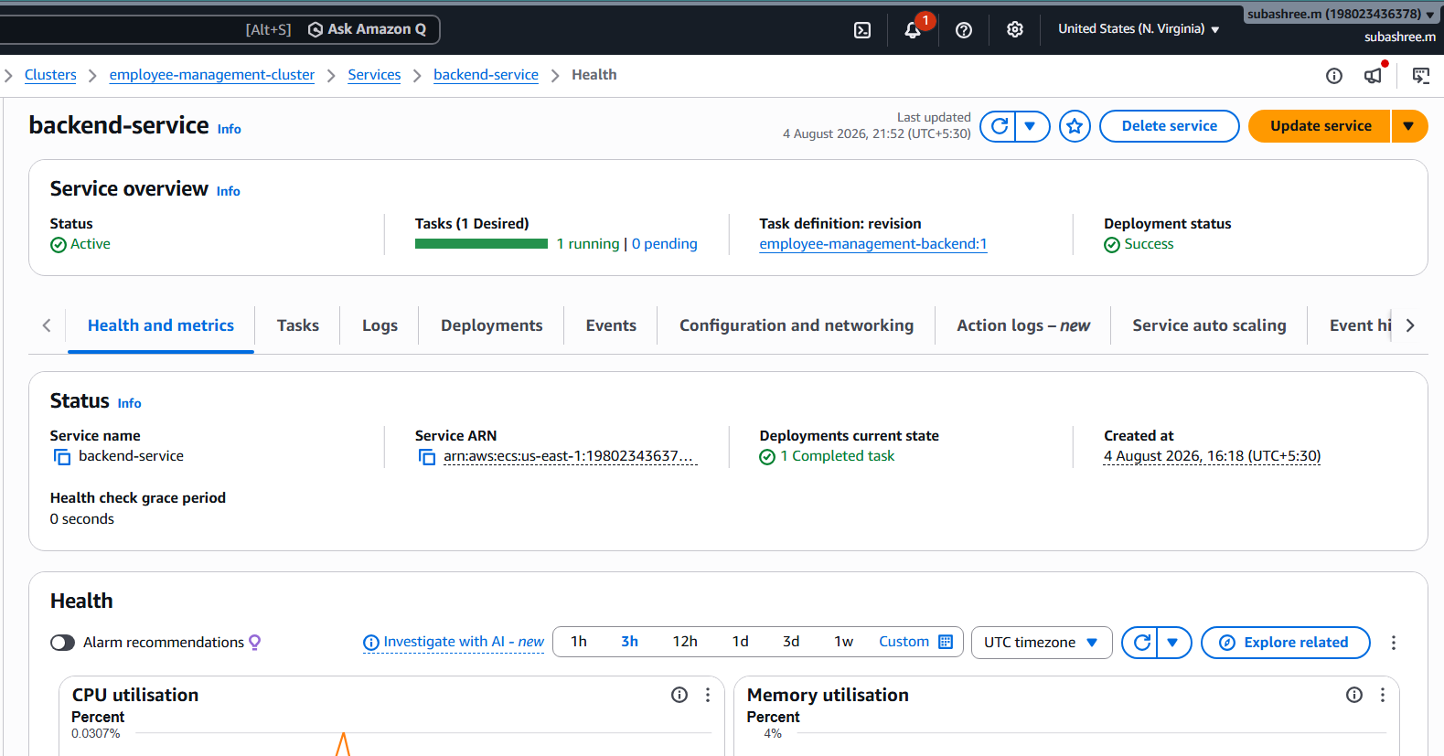

Frontend

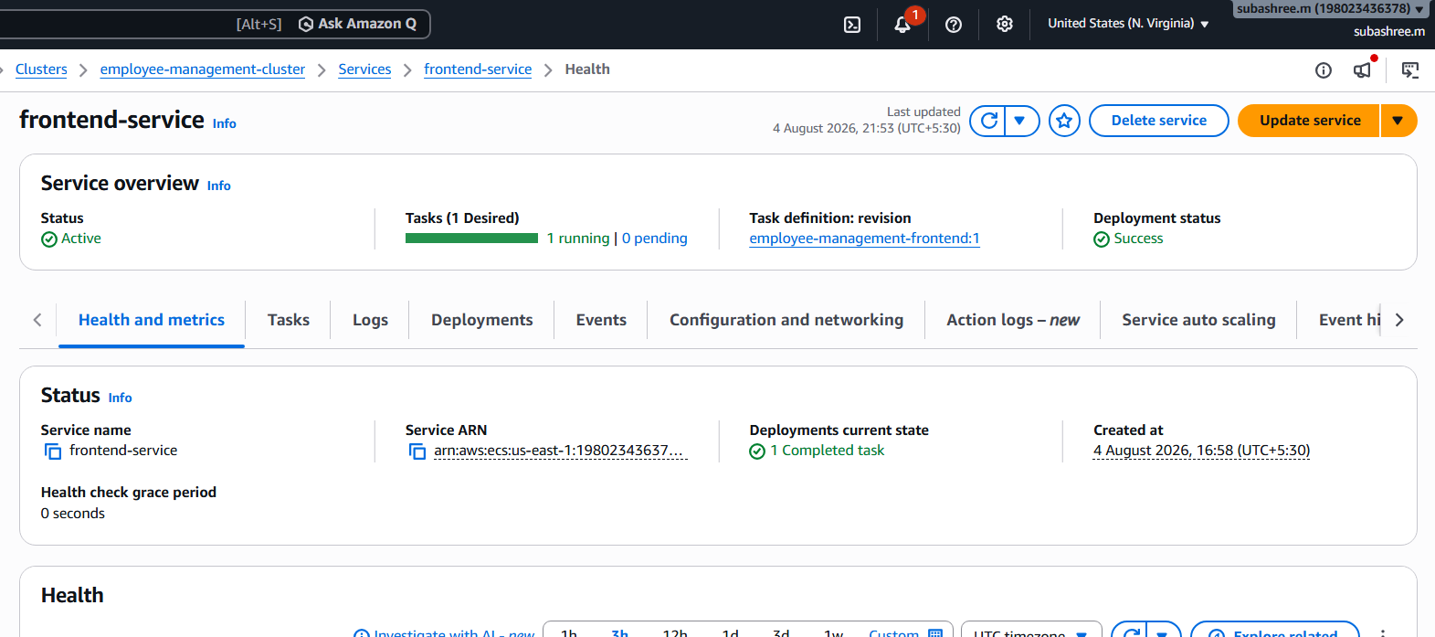

Amazon ECS Tasks

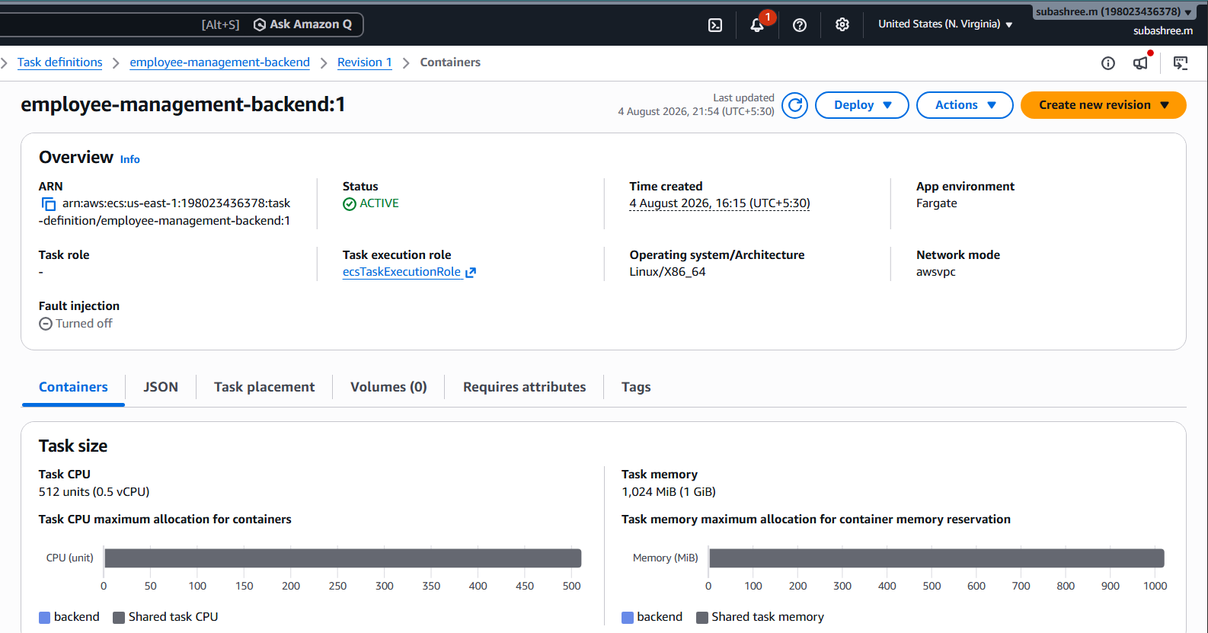

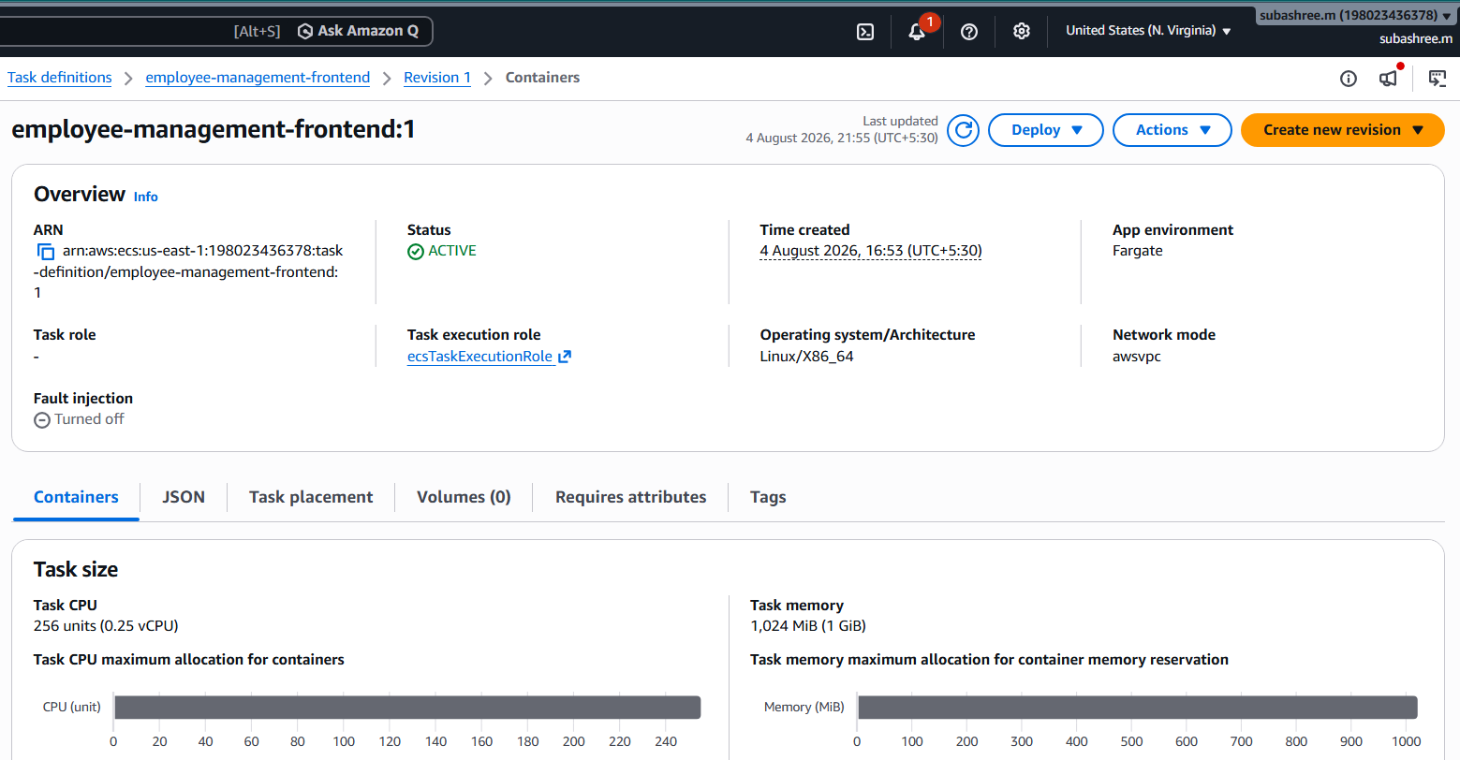

Amazon RDS Database

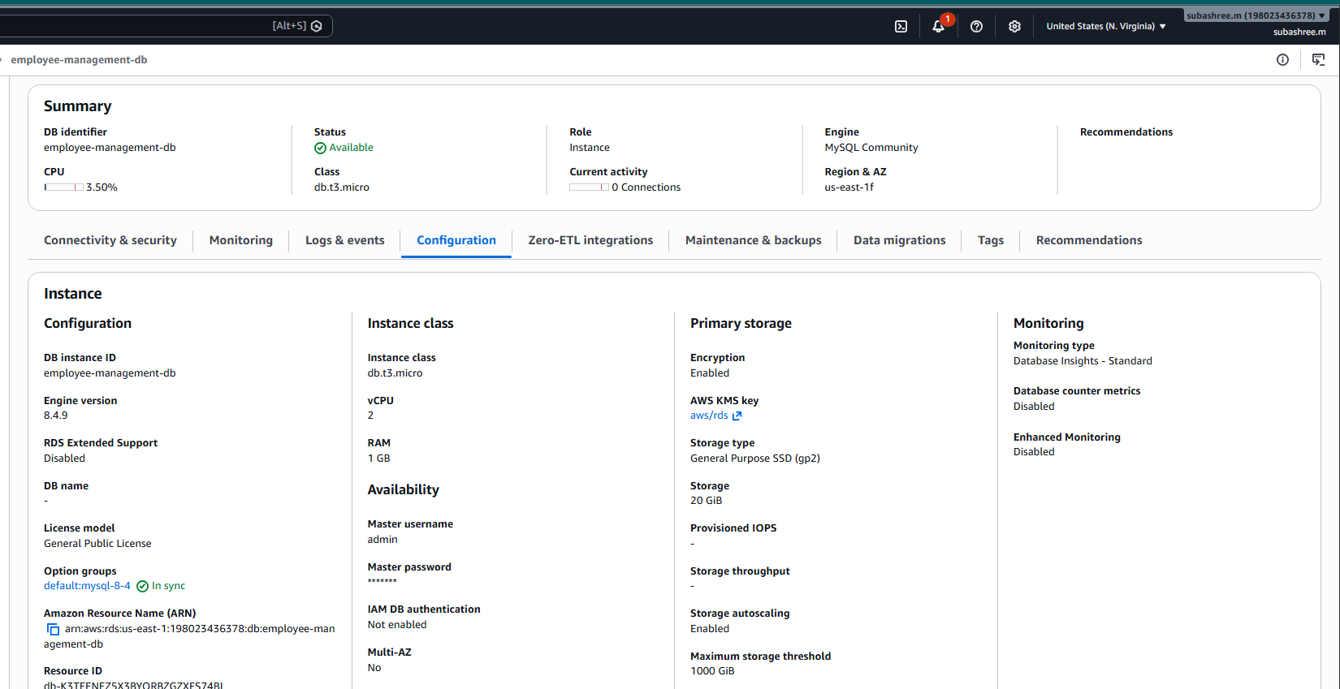

Application Load Balancer - Backend

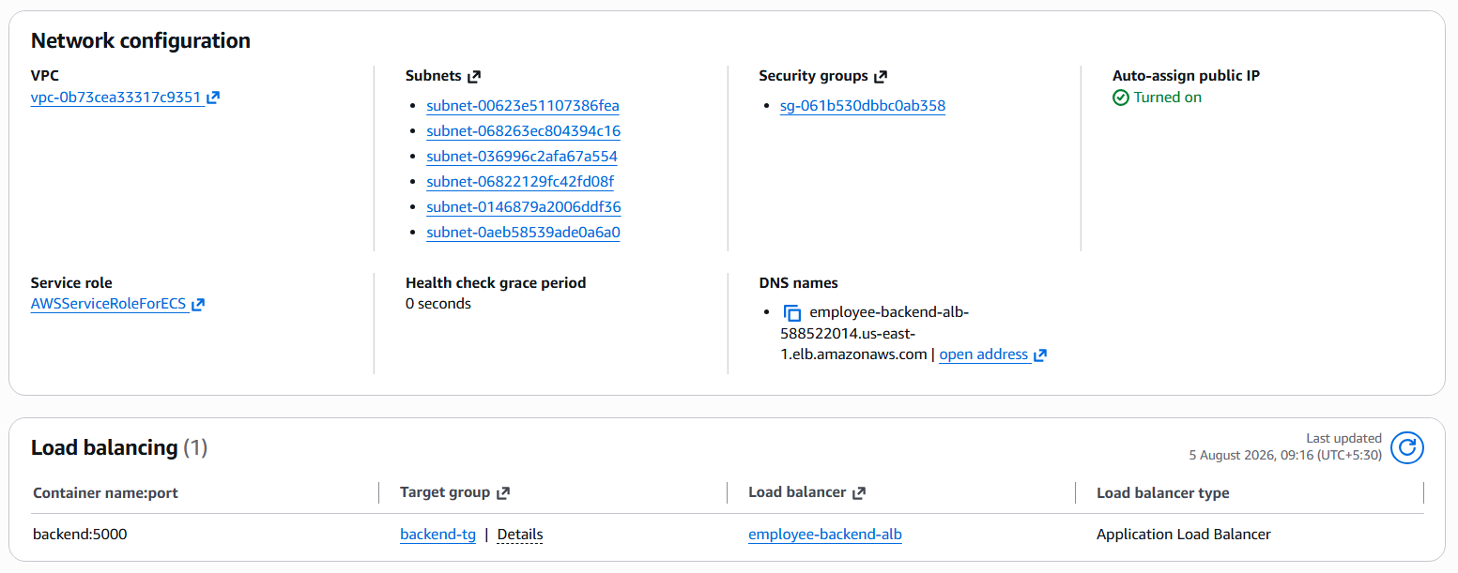
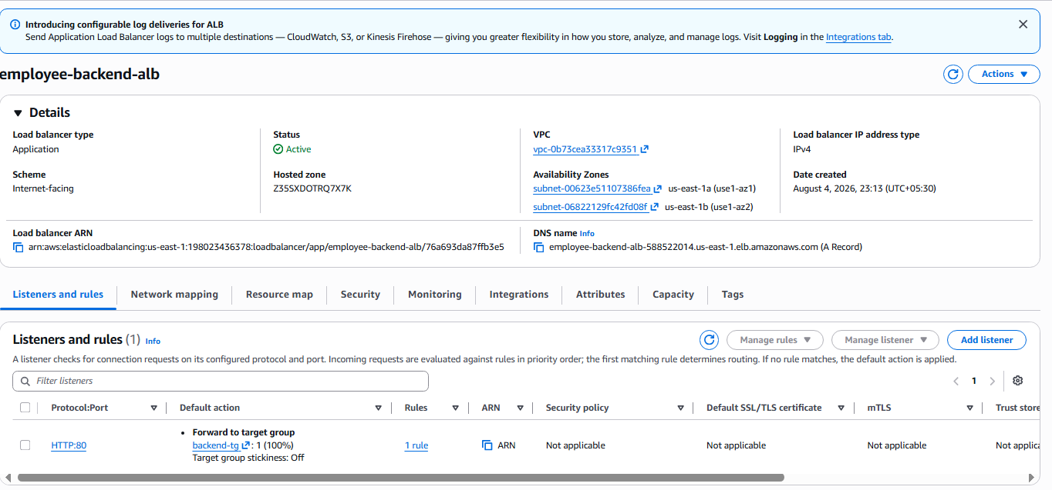

Employee Management Home Page

Backend ALB url:

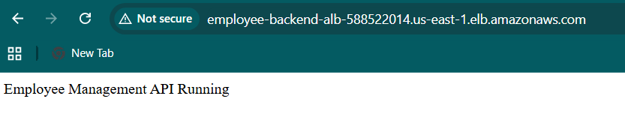
Home page:

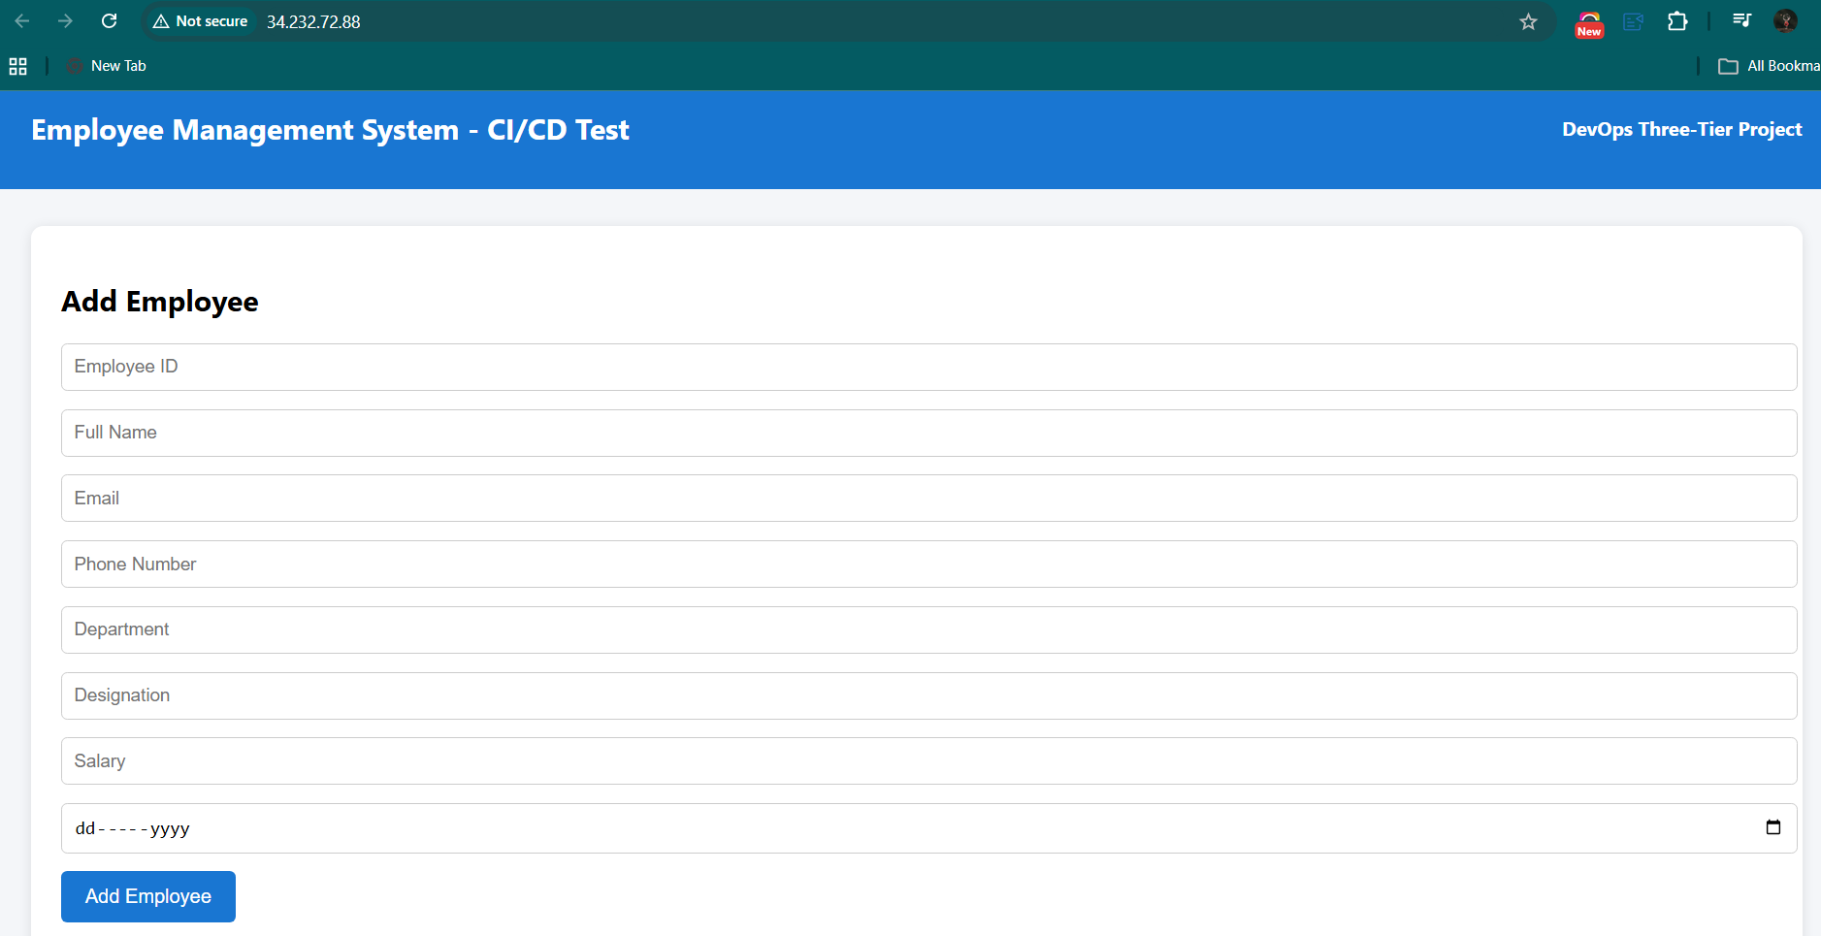

Add Employee

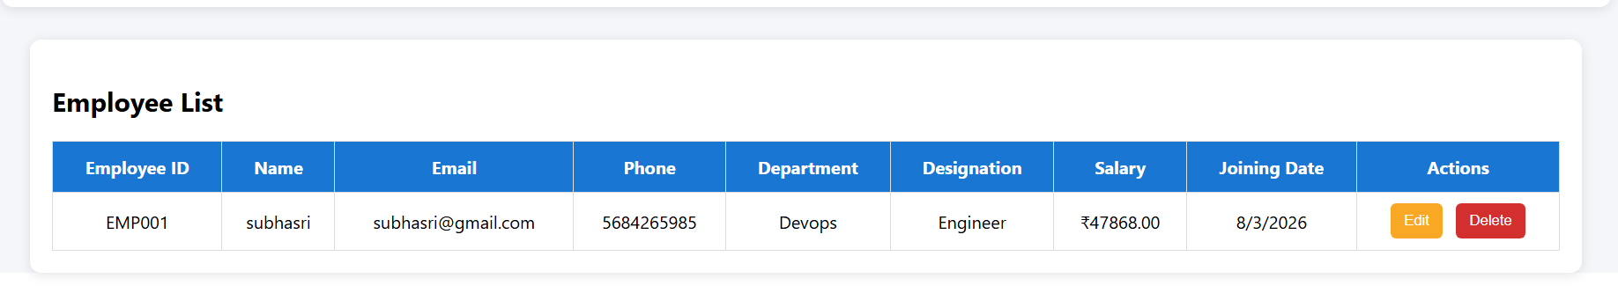

Update Employee
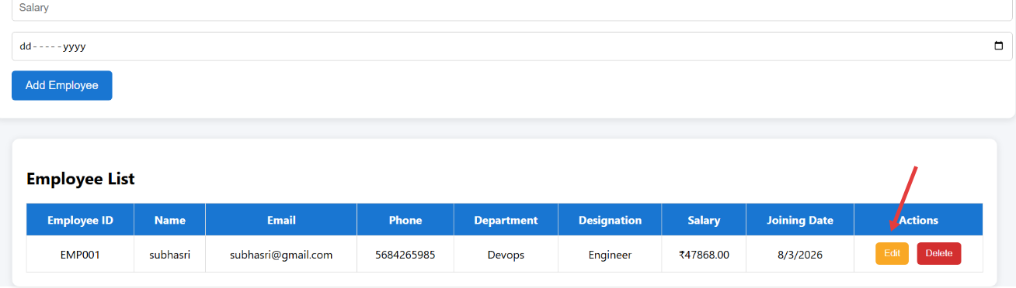

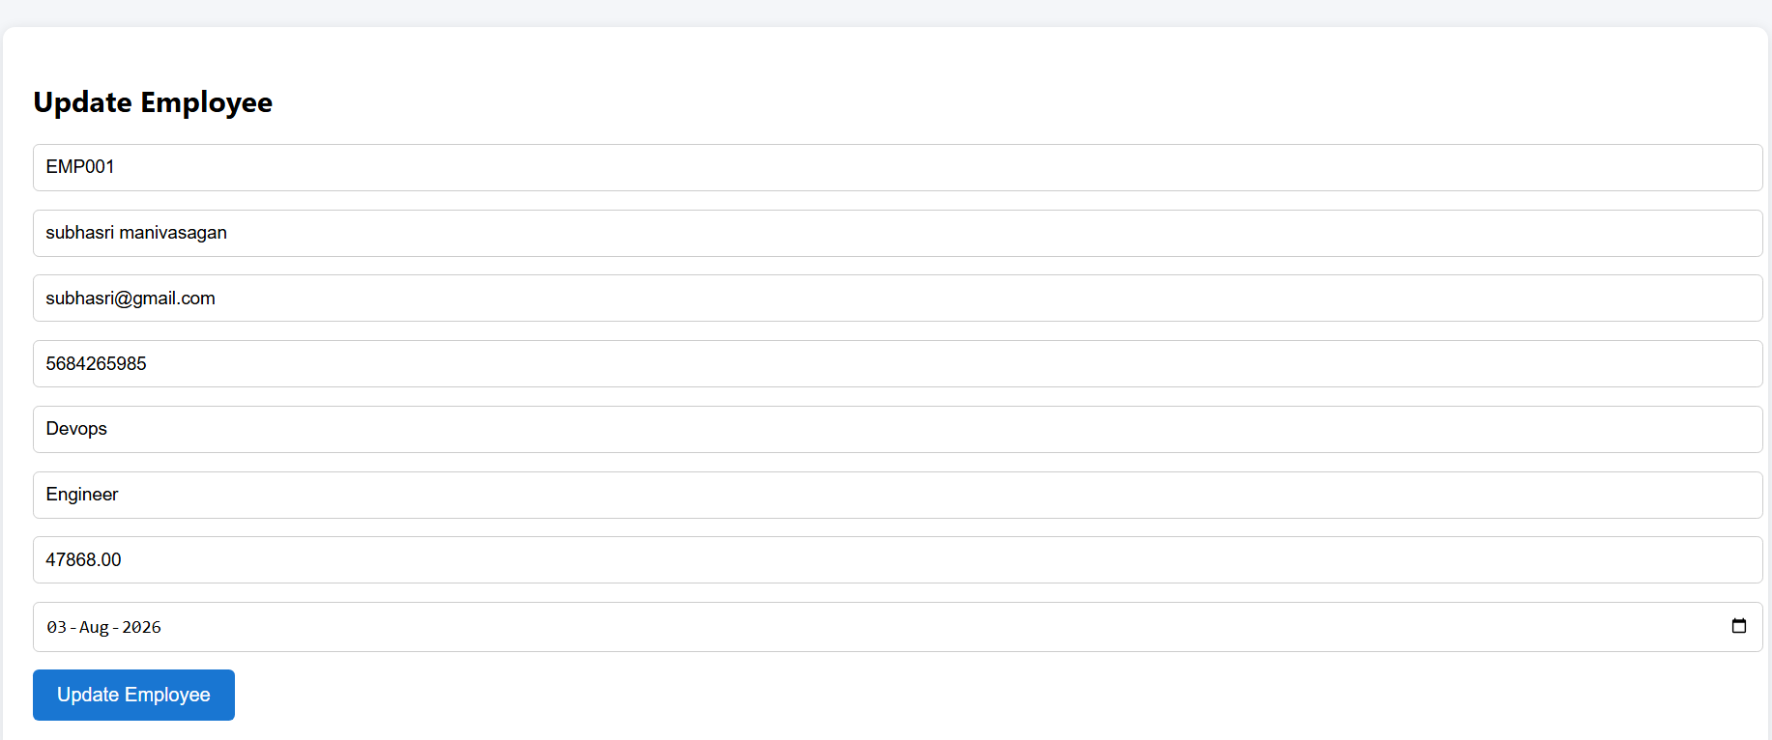

( updated the name)

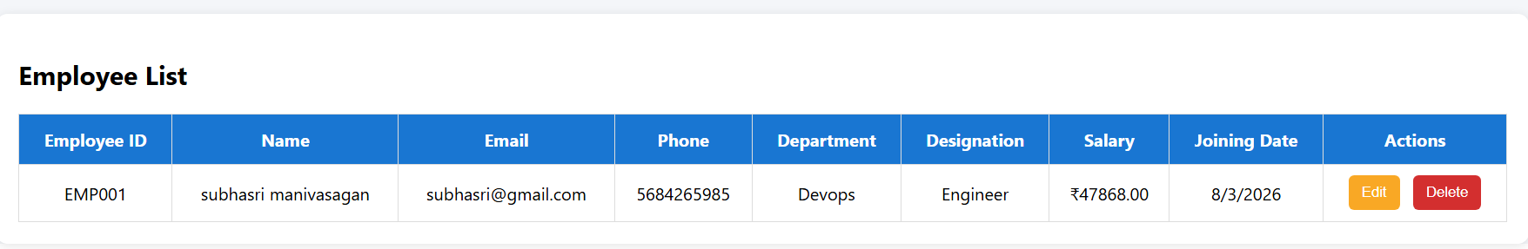

Delete employee

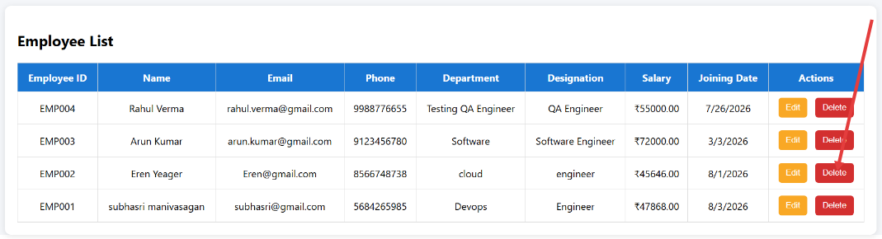

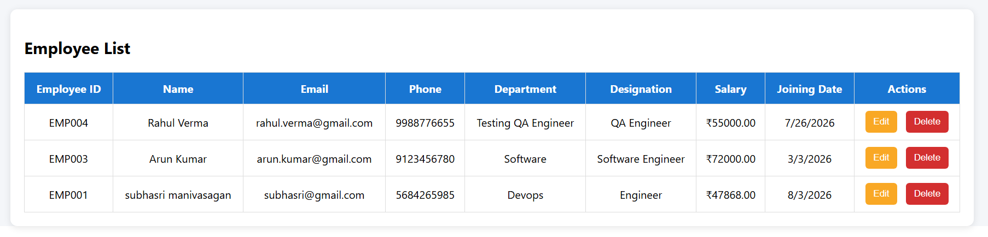

12. Troubleshooting and Solutions
During the implementation of the Employee Management System, several technical issues were encountered. Each issue was analyzed and resolved successfully, improving the overall stability and deployment process of the application.
Issue | Solution
Docker image build failed due to insufficient disk space. | Increased the EC2 storage volume and removed unused Docker images to free disk space.
Backend could not connect to the Amazon RDS database. | Verified the database endpoint, credentials, environment variables, and updated the RDS security group to allow ECS access.
CORS errors occurred between the React frontend and Flask backend. | Enabled CORS support in the Flask application to allow frontend requests.
Amazon ECS services were not using the latest Docker images. | Updated the Jenkins pipeline to automatically force a new ECS deployment after pushing images to Amazon ECR.
Frontend was unable to communicate with the backend API. | Updated the frontend API endpoint to use the Application Load Balancer (ALB) DNS name.
Jenkins failed to authenticate with Amazon ECR. | Configured AWS credentials correctly and authenticated Jenkins using the AWS CLI before pushing Docker images.
Jenkins container became compromised during testing. | Removed the compromised container, rebuilt the Jenkins Docker image, and reconfigured the Jenkins environment.
Application was inaccessible after deployment. | Verified ECS tasks, ALB target groups, security groups, and networking configuration to restore application connectivity.

These troubleshooting activities provided practical experience in debugging, AWS service configuration, Docker container management, and CI/CD pipeline automation.

- Conclusion

The AWS Employee Management System was successfully developed and deployed using modern AWS services and DevOps practices. The project demonstrated the implementation of a three-tier architecture, Docker containerization, Amazon ECS deployment, Amazon RDS database integration, and Jenkins CI/CD automation.
This project provided practical experience in cloud deployment, container orchestration, and continuous integration and deployment, strengthening knowledge of AWS and DevOps concepts.

